Abellera, Joshua Beaver Q.

Menese, James Joash F.

Machine Problem (Python): Problem 1

Python Script file

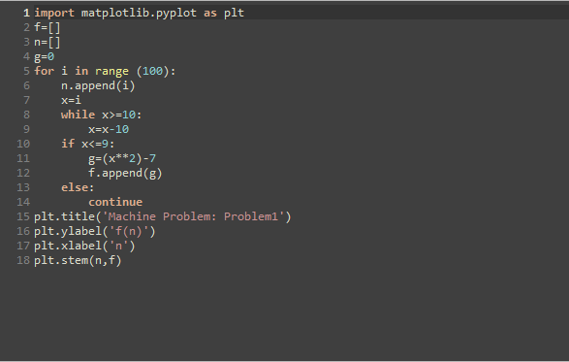

Output plot

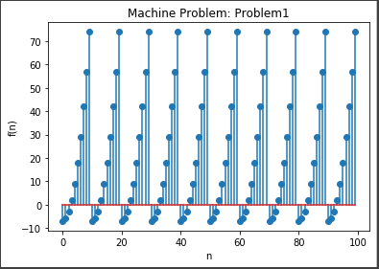

Observation:

In this graph, we have observed that there are only 9 y-components on the whole graph, due to the 2nd piecewise function. The second piecewise function is simply repeating the function for n<=9 because the second function is described as the function of n-10 until it meets the condition for the first function. This means that the graph has only has a range of {-7, -6, -3,2,9,18,29,42,57,74}. The graph is also a series of a left side of a quadratic function opening upward.